TRANSFORMER FLEET HEALTH
Predictive Analytics Summary Report — 500 Transformers

1. Executive Summary
This report analyzes 500 power transformers (11 kV class) using 11 sensor/asset features and one cooling-mode feature to classify Health_Status as Healthy, Warning, or Critical. The dataset was complete (no missing values, no duplicates) and required minimal cleaning.
24.4% of the fleet is currently Critical and 44.6% is in Warning — only 31% is fully Healthy. Two degradation pathways drive this: an aging/insulation cluster (age, moisture, dissolved gas, vibration, partial discharge) and an electrical-loading/thermal cluster (current, load, temperature). Vibration, oil/winding temperature, and dissolved gas are the strongest health predictors across every method tested. A baseline Random Forest classifier reached 96.8% test accuracy, confirming a production predictive-maintenance model is readily achievable.
Key Takeaway: Prioritize inspection of the 122 Critical-flagged units, deploy the validated model as a live scoring service, and invest sensor budget in vibration, temperature, and dissolved-gas monitoring — the highest-value signals identified.

2. Data Overview & Quality
Property | Value
Rows / Columns | 500 / 15
Missing values | 0
Duplicate rows | 0
Target variable | Health_Status (Healthy / Warning / Critical)
Problem type | Multi-class Classification

The data is clean and complete — no missing values, duplicates, or invalid entries were found, so cleaning effort focused on validation rather than repair. Voltage_kV is constant (11.0 kV) across all units and was dropped as non-informative. Cooling_Status was label-encoded; numeric features were standardized for scale-sensitive models. IQR outlier screening flagged zero outliers on every numeric feature.

3. Descriptive Statistics
Variable | Mean | Median | Std Dev | Skew | Outliers
Age_Years | 15.04 | 15.00 | 8.83 | 0.07 | 0
Oil_Temperature_C | 76.98 | 77.45 | 8.04 | -0.09 | 0
Winding_Temperature_C | 86.83 | 87.30 | 8.28 | -0.12 | 0
Ambient_Temperature_C | 30.16 | 30.00 | 6.91 | 0.02 | 0
Current_A | 302.18 | 300.55 | 86.81 | 0.02 | 0
Load_Percentage | 67.17 | 67.00 | 19.32 | 0.02 | 0
Oil_Level_Percentage | 93.46 | 93.50 | 3.77 | -0.06 | 0
Moisture_ppm | 21.12 | 20.90 | 7.40 | 0.08 | 0
Dissolved_Gas_ppm | 322.95 | 317.55 | 98.75 | 0.04 | 0
Vibration_mm_s | 3.19 | 3.21 | 0.81 | -0.08 | 0
Partial_Discharge_pC | 51.94 | 50.15 | 19.04 | 0.04 | 0

All features are close to symmetric (|skew| < 0.15) with no IQR outliers, indicating readings span the full healthy-to-critical range rather than clustering around a "normal" value with rare extremes.

4. Visual Analysis

4.1 Feature Distributions
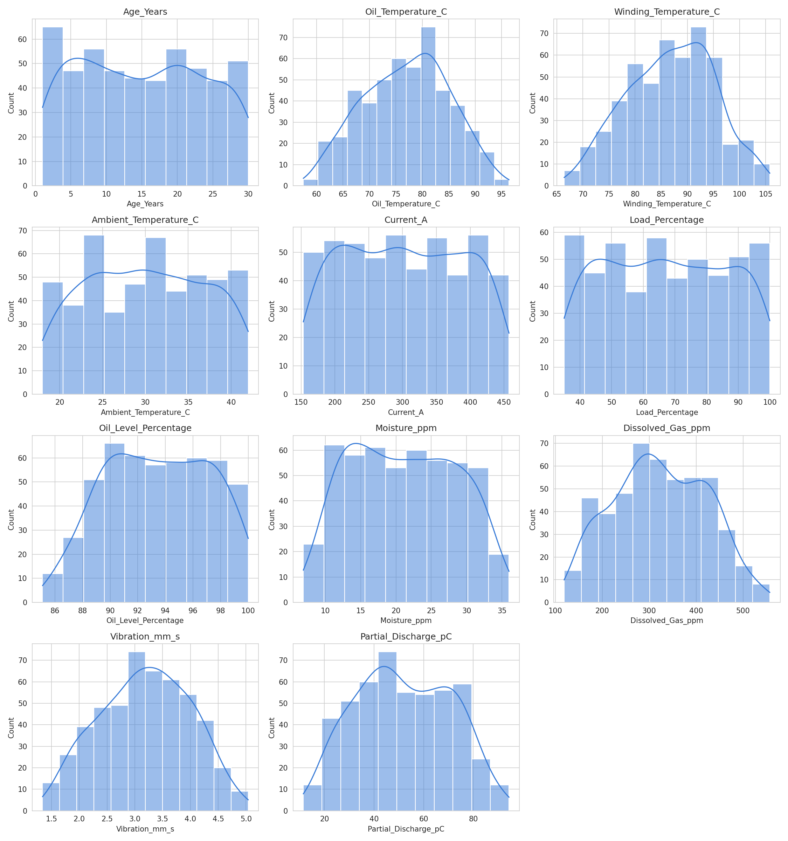
Figure 1. Distribution of all numeric sensor features.
Distributions are broad and roughly symmetric with no sharp "normal" peak — meaning simple fixed-threshold alarms will be unreliable and a multivariate model is needed to separate health classes.

4.2 Key Indicators by Health Status
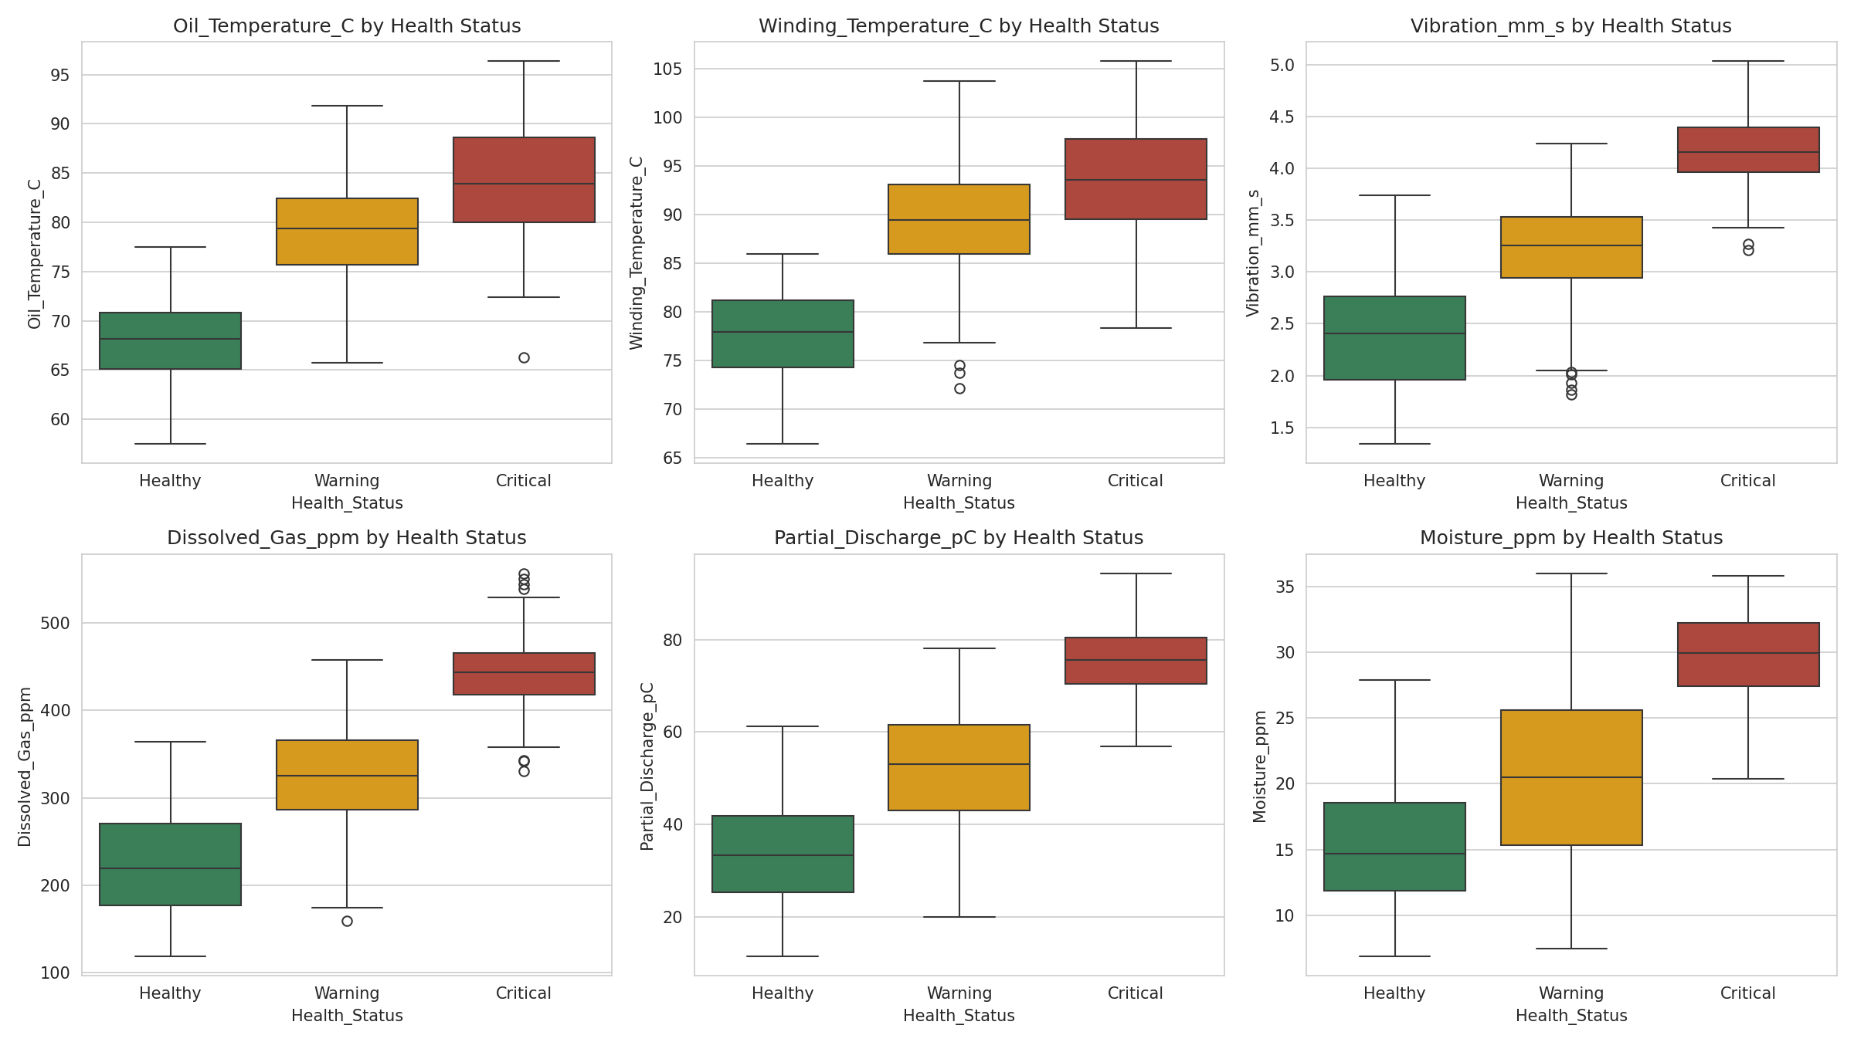
Figure 2. Six fault indicators compared across Healthy / Warning / Critical.
Medians step clearly upward (or downward) from Healthy to Critical for every variable shown, confirming these are strong, monotonic health indicators suitable for both a diagnostic dashboard and model features.

4.3 Correlation Structure
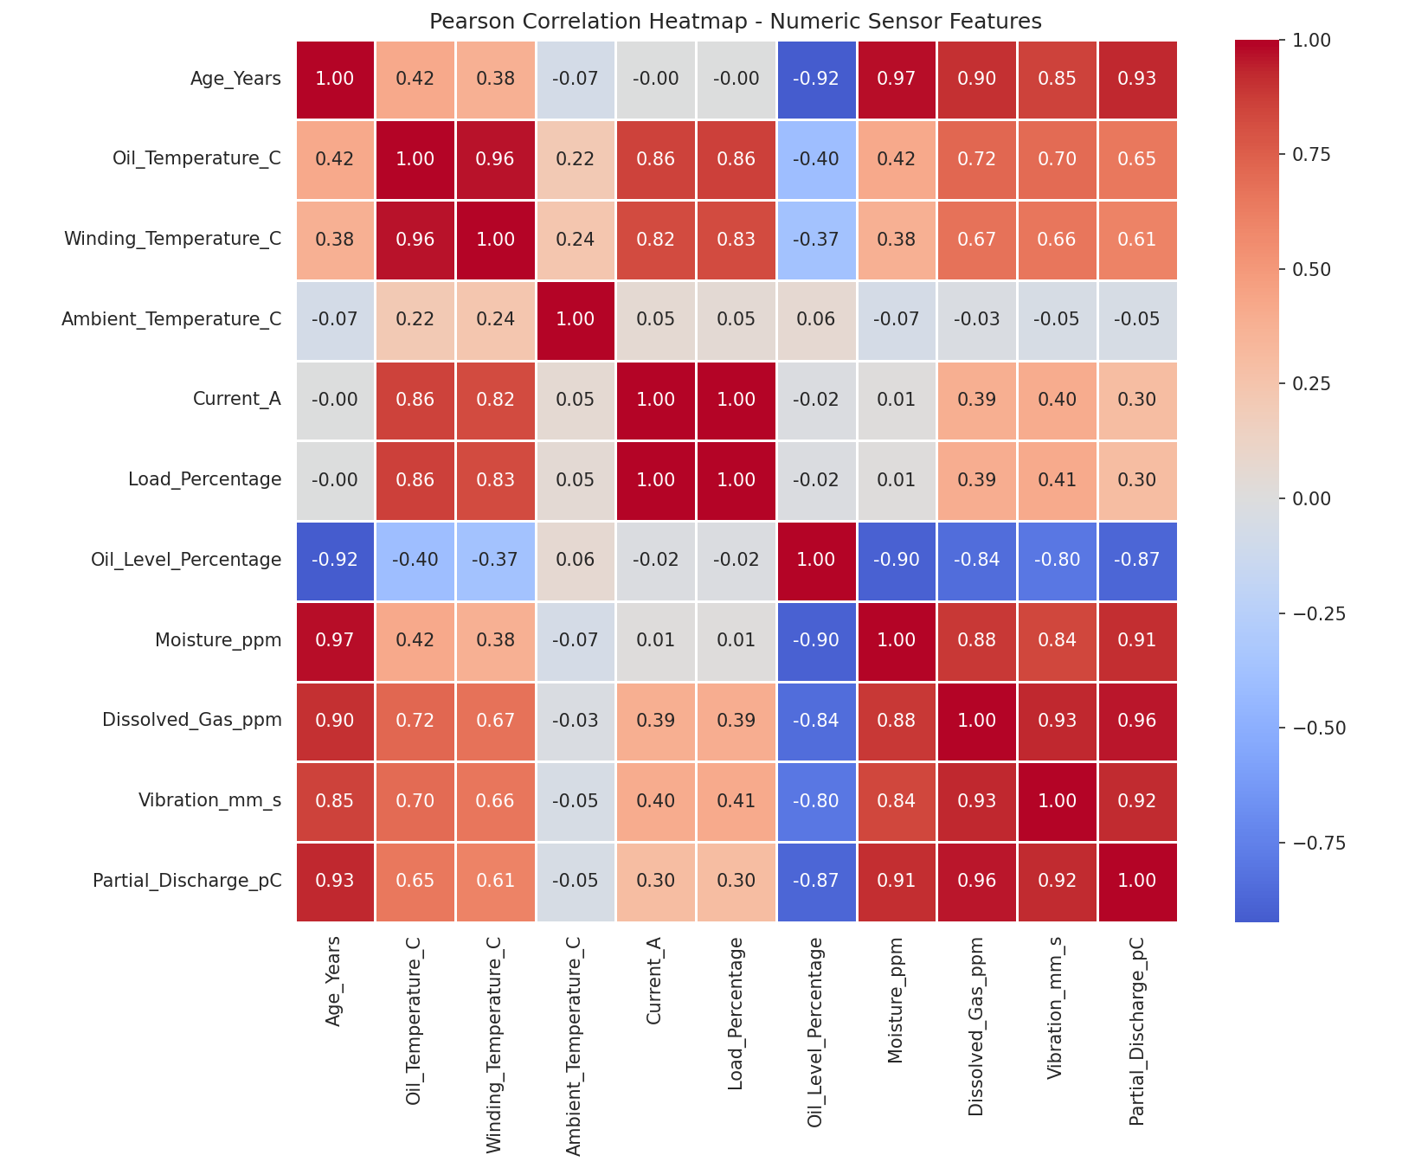
Figure 3. Pearson correlation heatmap of numeric features.
Two clusters dominate: an electrical-loading cluster (current, load, temperature) and an aging/degradation cluster (age, moisture, gas, vibration, partial discharge). Current_A and Load_Percentage are near-duplicate measurements (r = 0.999).
Variable A | Variable B | r
Current_A | Load_Percentage | 1.00
Age_Years | Moisture_ppm | 0.97
Oil_Temperature_C | Winding_Temperature_C | 0.96
Dissolved_Gas_ppm | Partial_Discharge_pC | 0.96
Age_Years | Partial_Discharge_pC | 0.93
Dissolved_Gas_ppm | Vibration_mm_s | 0.93

4.4 Feature Importance
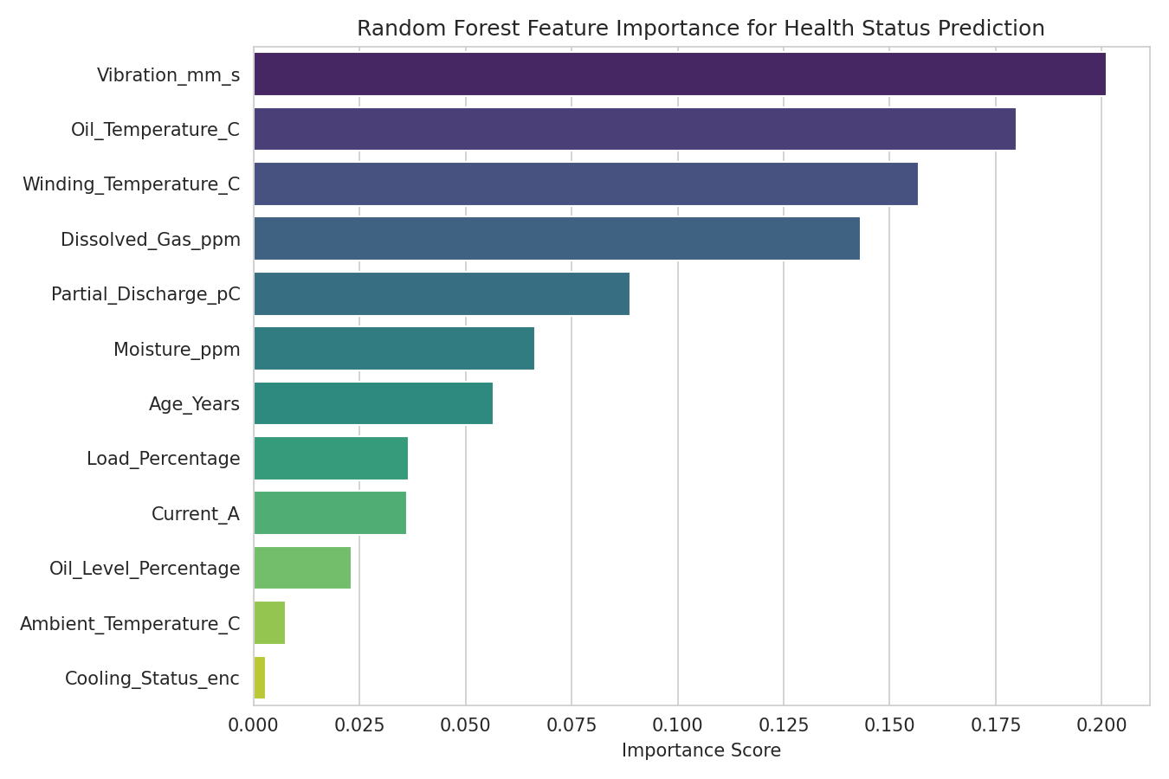
Figure 4. Random Forest feature importance for Health_Status.
Feature | RF Importance
Vibration_mm_s | 0.201
Oil_Temperature_C | 0.180
Winding_Temperature_C | 0.157
Dissolved_Gas_ppm | 0.143
Partial_Discharge_pC | 0.089
Moisture_ppm | 0.066
Vibration, oil/winding temperature, and dissolved gas dominate — Ambient_Temperature_C and Cooling_Status contribute almost nothing, since they are reactive/contextual rather than causal signals.

4.5 Fleet Health & Cooling Mix
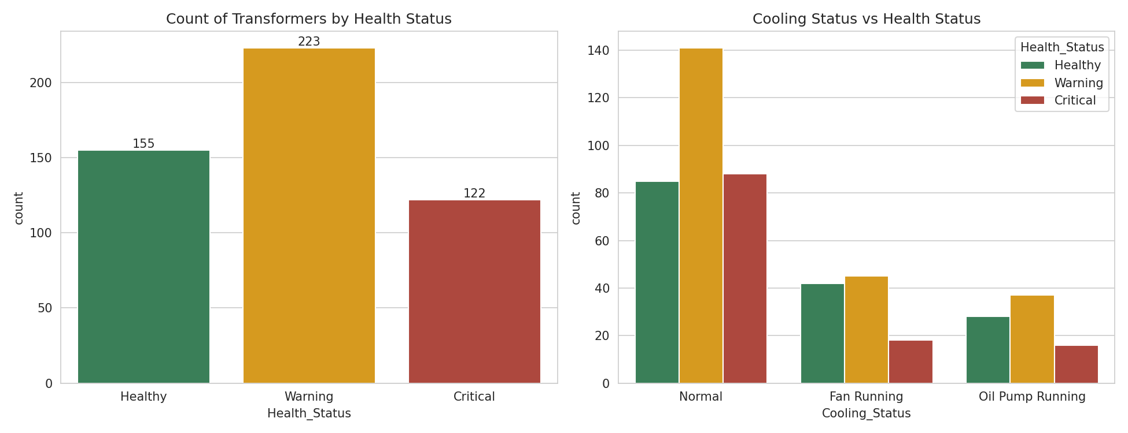
Figure 5. Transformer counts by Health Status, and Cooling Status split by Health Status.
Warning is the largest group (223, 44.6%), followed by Healthy (155, 31.0%) and Critical (122, 24.4%). Cooling mode shows only a marginal association with health (Chi-square p = 0.052), consistent with its low feature importance.

4.6 Model Performance
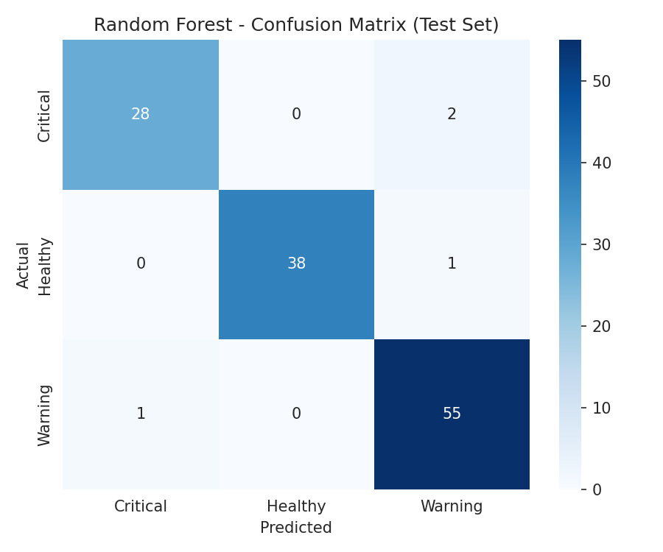
Figure 6. Random Forest confusion matrix on held-out test data.
Model | Accuracy | Precision | Recall | F1
Random Forest | 96.8% | 97.1% | 96.3% | 96.7%
Logistic Regression | 94.4% | 94.8% | 94.0% | 94.4%

Random Forest outperforms Logistic Regression, which is held back by multicollinearity among sensor features. Tree-based ensembles (Random Forest, XGBoost, LightGBM) are recommended for production use since they handle correlated inputs natively and capture non-linear thresholds.

5. Statistical Validation
One-way ANOVA (H0: equal means across Healthy/Warning/Critical) confirms every numeric feature differs significantly by health group (p < 0.05); the strongest discriminators by F-statistic are shown below — closely matching the feature-importance ranking above.
Variable | F-statistic | p-value | Result
Dissolved_Gas_ppm | 558.5 | <0.0001 | Significant
Vibration_mm_s | 534.4 | <0.0001 | Significant
Partial_Discharge_pC | 506.3 | <0.0001 | Significant
Oil_Temperature_C | 382.7 | <0.0001 | Significant
Winding_Temperature_C | 336.7 | <0.0001 | Significant
Age_Years | 271.0 | <0.0001 | Significant

A Chi-square test of Cooling_Status vs. Health_Status (χ² = 9.41, df = 4, p = 0.052) found no strong association — cooling mode is a reactive symptom, not an independent risk driver.

6. Business Insights & Recommendations
- 69% of the fleet shows some degradation (Warning + Critical) — this is a programmatic aging issue, not isolated bad units.
- Prioritize inspection of the 122 Critical units within 30 days, ranked by dissolved gas and vibration magnitude.
- Deploy the Random Forest model as a live scoring service to shift from calendar-based to condition-based maintenance.
- Invest sensor budget in vibration, temperature, and dissolved-gas monitoring — the highest-value signals — over ambient temperature or cooling status.
- Track KPIs: % fleet Critical, mean dissolved gas/vibration trend, and model recall on the Critical class specifically (missed Critical units are the costliest error).
- Use the clear age–health relationship to support age-tiered capital replacement planning.

7. Limitations & Future Work
- No timestamp field — this is a snapshot, not a time series, so trend-based early warning is not yet possible; collecting longitudinal data is the top priority for future work.
- Unusually clean, symmetric, zero-outlier data suggests this may be simulated or pre-processed; real deployment data should be expected to be noisier.
- Missing context (manufacturer, installation type, maintenance/failure history) would likely sharpen root-cause attribution.
- Next steps: SHAP/LIME explainability per prediction, XGBoost/LightGBM benchmarking, and a Power BI/Tableau dashboard for daily operational use.

